Lampiran

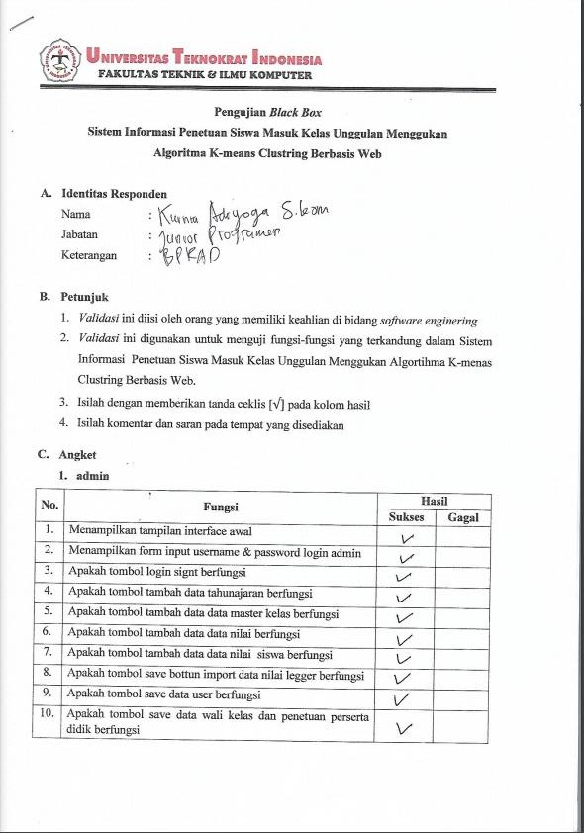

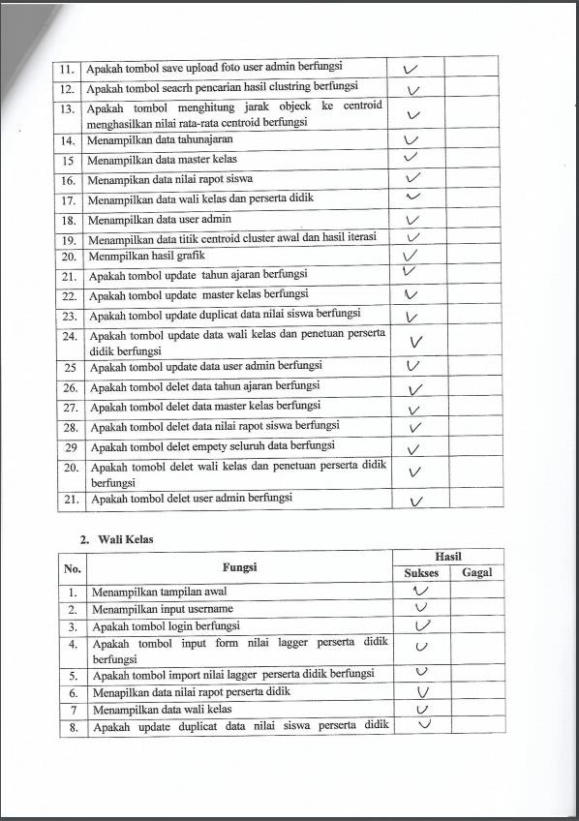

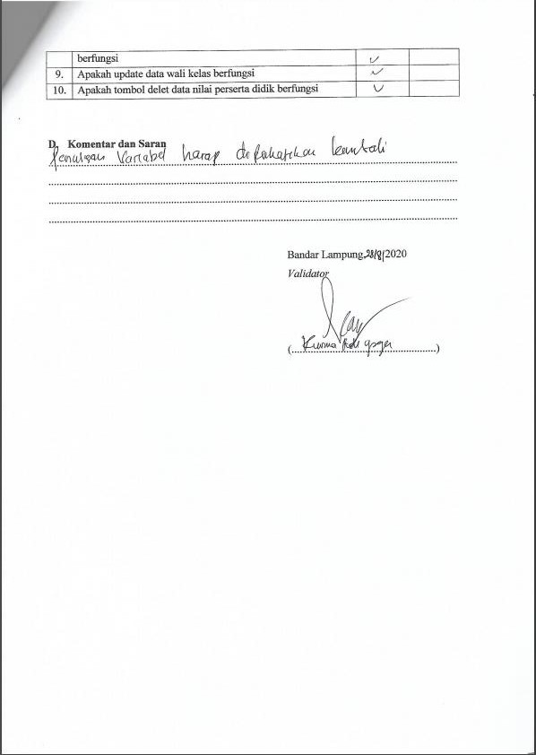

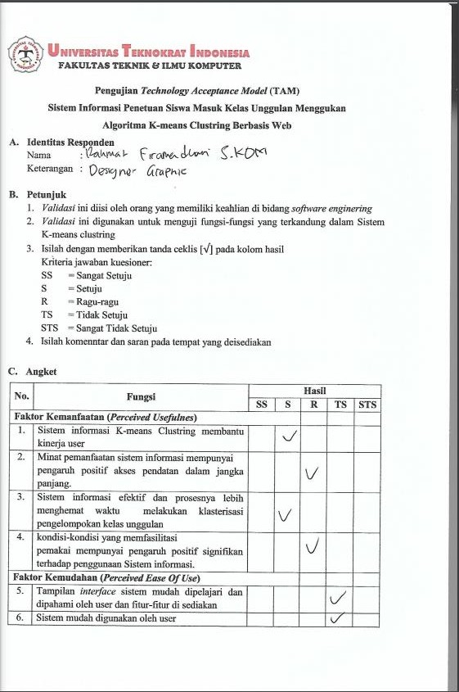

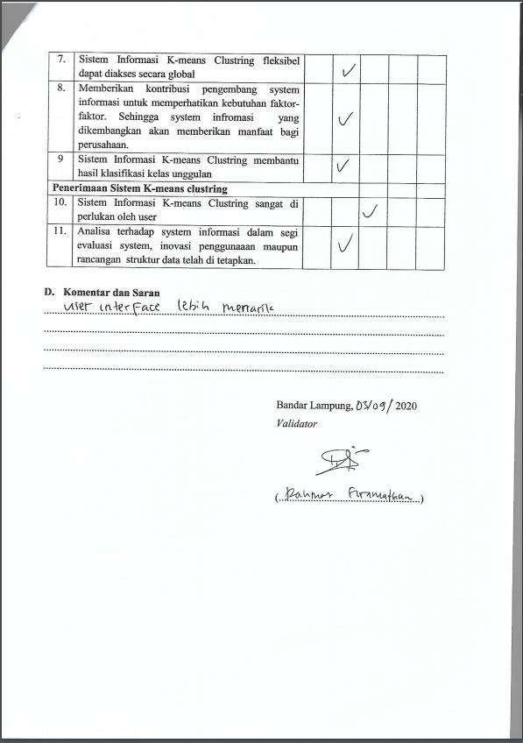

Tabel data nilai kelas A
No | Nama Siswa | AGAMA  DAN BP |  | PPKN |  | Bahasa  Indonesia |  | Matematika |  | IPA |  | IPS |  | BAHASA  INGGRIS |  | SENI  BUDAYA |  | PJOK |  | Prakarya
No | Nama Siswa | P | K | P | K | P | K | P | k | P | K | P | K | P | K | P | K | P | K | P | k | Jumlah | Rangking
1 | Afri Lestari | 78 | 78 | 86 | 83 | 88 | 88 | 80 | 78 | 78 | 85 | 83 | 83 | 83 | 83 | 80 | 85 | 79 | 80 | 84 | 90 | 1652 | 16
2 | Alief Adran Maulanan Iqbal | 80 | 80 | 81 | 86 | 88 | 88 | 85 | 88 | 79 | 80 | 88 | 83 | 88 | 83 | 82 | 86 | 81 | 84 | 85 | 90 | 1685 | 1
3 | Alip Satrio | 80 | 80 | 78 | 83 | 78 | 89 | 84 | 78 | 82 | 82 | 80 | 80 | 75 | 80 | 79 | 88 | 80 | 82 | 86 | 90 | 1634
4 | Amanda Setia Nata | 78 | 78 | 88 | 86 | 88 | 88 | 84 | 78 | 78 | 85 | 80 | 79 | 80 | 79 | 79 | 85 | 79 | 80 | 83 | 89 | 1644
5 | Andrea Firmansyah | 78 | 78 | 84 | 83 | 89 | 88 | 81 | 84 | 82 | 82 | 77 | 80 | 80 | 80 | 79 | 70 | 82 | 86 | 85 | 88 | 1636 | 10
6 | Ayu Eka Sari | 80 | 78 | 83 | 88 | 88 | 88 | 89 | 78 | 87 | 88 | 84 | 78 | 84 | 79 | 77 | 84 | 80 | 83 | 83 | 88 | 1667 | 10
7 | Bima Ilham Rahmatullah | 85 | 77 | 84 | 83 | 89 | 78 | 82 | 78 | 78 | 85 | 83 | 83 | 83 | 83 | 79 | 86 | 79 | 81 | 80 | 87 | 1643
8 | Calista Cahya Putri | 80 | 80 | 88 | 84 | 89 | 89 | 81 | 78 | 82 | 83 | 81 | 85 | 81 | 85 | 80 | 85 | 78 | 84 | 83 | 70 | 1646 | 9
9 | Deden maifiko Ilham | 78 | 78 | 78 | 80 | 88 | 88 | 82 | 89 | 82 | 80 | 78 | 85 | 78 | 70 | 78 | 87 | 77 | 77 | 82 | 92 | 1627
10 | Dody Kurniawan | 79 | 80 | 81 | 83 | 81 | 89 | 84 | 78 | 85 | 83 | 80 | 80 | 80 | 80 | 81 | 87 | 86 | 83 | 82 | 89 | 1651 | 8
11 | Enjalia Dwi Saputri | 80 | 80 | 84 | 86 | 89 | 88 | 83 | 89 | 84 | 83 | 82 | 80 | 82 | 80 | 79 | 83 | 84 | 83 | 70 | 87 | 1656 | 5
12 | Ferdi Suryanto | 78 | 88 | 78 | 83 | 88 | 88 | 79 | 78 | 84 | 81 | 80 | 79 | 75 | 86 | 85 | 85 | 79 | 83 | 84 | 89 | 1650
13 | Fiqi Fanizar | 80 | 80 | 81 | 86 | 88 | 89 | 85 | 87 | 84 | 85 | 84 | 79 | 86 | 79 | 80 | 85 | 83 | 77 | 70 | 88 | 1656 | 4
14 | Fitria Setia Ningsih | 80 | 80 | 86 | 88 | 81 | 88 | 78 | 78 | 84 | 85 | 78 | 78 | 78 | 85 | 80 | 87 | 79 | 81 | 84 | 93 | 1651 | 14
15 | Friska Adelia Safitri | 80 | 80 | 92 | 88 | 89 | 89 | 83 | 78 | 84 | 88 | 84 | 83 | 84 | 86 | 80 | 87 | 79 | 81 | 70 | 87 | 1672 | 2
16 | M.Tedi Fadila Mora | 78 | 78 | 79 | 83 | 78 | 88 | 84 | 78 | 84 | 82 | 80 | 81 | 76 | 86 | 78 | 86 | 80 | 82 | 85 | 88 | 1634
17 | Marcheel Febriano | 79 | 80 | 79 | 83 | 88 | 70 | 79 | 88 | 78 | 88 | 78 | 79 | 83 | 86 | 78 | 85 | 79 | 80 | 84 | 83 | 1627
18 | Mawar Livia Wati | 80 | 78 | 88 | 80 | 86 | 88 | 80 | 88 | 79 | 80 | 80 | 79 | 80 | 80 | 77 | 82 | 80 | 82 | 84 | 87 | 1638
19 | Muhamad Rezya Abdillah | 78 | 80 | 88 | 83 | 86 | 80 | 84 | 70 | 87 | 82 | 78 | 78 | 86 | 83 | 81 | 84 | 81 | 80 | 83 | 87 | 1639 | 16
20 | Nayla Aulia Khairani | 82 | 82 | 85 | 83 | 89 | 89 | 82 | 78 | 88 | 82 | 85 | 78 | 85 | 86 | 80 | 86 | 80 | 82 | 83 | 89 | 1674 | 12
21 | Nur Afni Aprilia | 81 | 81 | 85 | 83 | 88 | 81 | 85 | 77 | 82 | 85 | 82 | 85 | 82 | 85 | 77 | 85 | 80 | 82 | 70 | 88 | 1644 | 13
22 | Renaldi Aditya Pratama | 88 | 88 | 81 | 83 | 89 | 70 | 86 | 78 | 87 | 83 | 80 | 85 | 80 | 86 | 79 | 86 | 86 | 84 | 82 | 89 | 1670 | 6
23 | Rendy Dwi Saputra | 88 | 79 | 81 | 86 | 89 | 88 | 78 | 78 | 82 | 85 | 80 | 80 | 83 | 83 | 77 | 86 | 79 | 81 | 82 | 85 | 1650
24 | Riski Sulaiman | 80 | 78 | 81 | 83 | 89 | 81 | 81 | 80 | 80 | 80 | 80 | 80 | 78 | 80 | 88 | 81 | 81 | 85 | 84 | 85 | 1635
25 | Rismawati | 78 | 78 | 91 | 88 | 80 | 88 | 82 | 78 | 87 | 85 | 80 | 79 | 80 | 80 | 79 | 88 | 85 | 81 | 70 | 84 | 1641 | 15
26 | Seftatio Ariangga | 80 | 78 | 80 | 80 | 88 | 88 | 80 | 88 | 81 | 80 | 80 | 83 | 86 | 86 | 79 | 84 | 80 | 83 | 82 | 84 | 1650
27 | Selfi Novita Sari | 80 | 80 | 86 | 88 | 88 | 89 | 83 | 79 | 88 | 82 | 80 | 79 | 86 | 79 | 80 | 87 | 84 | 81 | 70 | 87 | 1656
28 | Serlina | 80 | 88 | 84 | 84 | 78 | 88 | 82 | 88 | 79 | 85 | 81 | 80 | 81 | 80 | 80 | 85 | 84 | 81 | 83 | 89 | 1660 | 3
29 | Soleh Arifin | 78 | 88 | 80 | 80 | 89 | 86 | 82 | 78 | 88 | 80 | 80 | 85 | 83 | 85 | 80 | 70 | 80 | 70 | 83 | 89 | 1634
30 | Sri Ayu Lestari | 80 | 81 | 91 | 86 | 80 | 88 | 84 | 88 | 85 | 83 | 79 | 78 | 85 | 85 | 79 | 85 | 80 | 83 | 84 | 85 | 1669
31 | Suci Novianti | 79 | 78 | 84 | 84 | 89 | 88 | 83 | 88 | 80 | 83 | 79 | 80 | 79 | 85 | 81 | 86 | 84 | 79 | 85 | 84 | 1658
32 | Yuli Artanto | 78 | 78 | 81 | 83 | 89 | 89 | 82 | 78 | 79 | 82 | 81 | 80 | 83 | 80 | 79 | 85 | 80 | 80 | 83 | 87 | 1637

Tabel data nilai kelas B.

No | Nama Siswa | AGAMA  DAN BP |  | PPKN |  | Bahasa  Indonesia |  | Matematika |  | IPA |  | IPS |  | BAHASA  INGGRIS |  | SENI  BUDAYA |  | PJOK |  | Prakarya
No | Nama Siswa | P | K | P | K | P | K | P | k | P | K | P | K | P | K | P | K | P | K | P | k | Jumlah | Rangking
1 | Abdul Rohim | 83 | 78 | 80 | 78 | 89 | 88 | 88 | 88 | 88 | 88 | 83 | 78 | 83 | 77 | 77 | 88 | 78 | 78 | 81 | 85 | 1656
2 | Adilia Zamzami | 83 | 81 | 92 | 88 | 88 | 89 | 87 | 87 | 78 | 94 | 81 | 78 | 87 | 88 | 81 | 88 | 79 | 80 | 89 | 89 | 1707 | 2
3 | Agnes Syafitri | 81 | 80 | 84 | 78 | 89 | 88 | 89 | 88 | 89 | 84 | 81 | 80 | 81 | 85 | 81 | 87 | 80 | 80 | 85 | 87 | 1677
4 | Albareth Chandr Alifinando | 79 | 85 | 84 | 78 | 88 | 89 | 89 | 89 | 88 | 88 | 79 | 85 | 78 | 77 | 79 | 87 | 82 | 86 | 82 | 82 | 1674 | 8
5 | Angger Wahyudi | 77 | 80 | 81 | 84 | 88 | 89 | 88 | 89 | 88 | 89 | 77 | 80 | 80 | 79 | 77 | 88 | 81 | 85 | 83 | 84 | 1667
6 | Anggun Citra Dewi | 82 | 80 | 89 | 78 | 89 | 88 | 89 | 88 | 88 | 88 | 82 | 80 | 79 | 77 | 82 | 88 | 78 | 79 | 88 | 85 | 1677 | 15
7 | Ardi Yudha Pratama | 76 | 83 | 82 | 78 | 88 | 88 | 89 | 88 | 78 | 89 | 76 | 83 | 84 | 88 | 76 | 84 | 78 | 80 | 86 | 84 | 1658 | 4
8 | Aulia Dita Anggraini | 79 | 80 | 81 | 78 | 89 | 88 | 89 | 88 | 89 | 89 | 79 | 80 | 84 | 82 | 79 | 87 | 82 | 84 | 87 | 83 | 1677 | 11
9 | Daffo Alif Zackaria | 78 | 85 | 82 | 89 | 89 | 89 | 89 | 89 | 88 | 88 | 78 | 85 | 78 | 77 | 78 | 87 | 80 | 83 | 83 | 84 | 1679
10 | Dea Fina Yulianti | 80 | 80 | 84 | 78 | 89 | 89 | 83 | 89 | 89 | 81 | 80 | 80 | 79 | 79 | 80 | 86 | 78 | 80 | 88 | 88 | 1660 | 13
11 | Dini | 82 | 83 | 83 | 89 | 88 | 88 | 89 | 88 | 88 | 89 | 82 | 83 | 78 | 79 | 82 | 87 | 79 | 80 | 88 | 89 | 1694
12 | Edo Riyadi | 83 | 78 | 79 | 78 | 89 | 88 | 89 | 78 | 88 | 88 | 83 | 78 | 79 | 79 | 77 | 87 | 79 | 82 | 85 | 87 | 1654
13 | Edwar Parel Kurnia | 88 | 83 | 85 | 87 | 89 | 77 | 89 | 78 | 89 | 88 | 88 | 83 | 84 | 79 | 77 | 87 | 79 | 81 | 83 | 85 | 1679 | 12
14 | Frenky Rendi Saputra | 79 | 85 | 78 | 78 | 89 | 89 | 89 | 78 | 88 | 81 | 79 | 85 | 78 | 77 | 79 | 85 | 81 | 85 | 83 | 84 | 1650
15 | Galih Justisyo Sitanggang | 77 | 85 | 83 | 78 | 89 | 77 | 89 | 88 | 89 | 89 | 77 | 85 | 79 | 77 | 77 | 85 | 80 | 83 | 87 | 84 | 1658 | 10
16 | Geo Ferbriansyah | 78 | 83 | 84 | 78 | 89 | 88 | 83 | 87 | 88 | 78 | 78 | 83 | 84 | 88 | 78 | 87 | 81 | 83 | 87 | 84 | 1669 | 3
17 | Ido Saputra | 78 | 78 | 79 | 88 | 89 | 88 | 78 | 79 | 70 | 88 | 78 | 78 | 78 | 78 | 77 | 87 | 81 | 85 | 79 | 79 | 1615
18 | Imelda isviyani | 78 | 78 | 80 | 88 | 89 | 88 | 79 | 81 | 88 | 86 | 78 | 78 | 80 | 85 | 78 | 89 | 78 | 78 | 88 | 88 | 1655 | 7
19 | Indri Kharisma Dewi | 80 | 80 | 92 | 88 | 88 | 89 | 82 | 84 | 87 | 94 | 85 | 88 | 85 | 88 | 85 | 91 | 81 | 85 | 93 | 94 | 1739 | 1
20 | Listiana | 85 | 85 | 82 | 78 | 89 | 89 | 81 | 81 | 89 | 89 | 85 | 85 | 81 | 85 | 85 | 88 | 79 | 80 | 90 | 89 | 1695 | 5
21 | Metha Purnama Sari | 84 | 83 | 85 | 77 | 89 | 88 | 79 | 81 | 81 | 88 | 84 | 83 | 83 | 90 | 84 | 85 | 80 | 82 | 89 | 89 | 1684 | 6
22 | Muhammad Aldo Avandi | 88 | 80 | 86 | 78 | 89 | 88 | 88 | 81 | 70 | 89 | 88 | 80 | 80 | 77 | 79 | 86 | 80 | 83 | 84 | 84 | 1658
23 | Nanada Enggar Dwi Saputro | 78 | 80 | 78 | 78 | 89 | 88 | 81 | 81 | 88 | 89 | 78 | 80 | 78 | 77 | 78 | 89 | 78 | 78 | 83 | 87 | 1636
24 | Ricky Rivaldo | 81 | 83 | 81 | 80 | 89 | 89 | 79 | 85 | 81 | 89 | 81 | 83 | 80 | 77 | 81 | 87 | 78 | 78 | 83 | 85 | 1650
25 | Rinjani Fara Anggita | 78 | 78 | 82 | 78 | 89 | 89 | 78 | 81 | 88 | 80 | 78 | 78 | 77 | 77 | 78 | 86 | 79 | 80 | 84 | 87 | 1625
26 | Rizky Rivaldo | 77 | 78 | 80 | 88 | 89 | 88 | 78 | 79 | 88 | 88 | 77 | 78 | 77 | 77 | 77 | 85 | 80 | 80 | 84 | 88 | 1636
27 | Romi Romansah | 77 | 78 | 83 | 79 | 89 | 88 | 79 | 81 | 89 | 88 | 77 | 78 | 78 | 77 | 77 | 86 | 81 | 82 | 79 | 79 | 1625
28 | Rooney Wijaya | 81 | 83 | 82 | 88 | 89 | 88 | 80 | 81 | 88 | 78 | 81 | 83 | 80 | 79 | 81 | 88 | 80 | 81 | 90 | 85 | 1666 | 9
29 | Septi Rusmawati | 80 | 80 | 82 | 78 | 88 | 88 | 81 | 81 | 86 | 89 | 80 | 80 | 78 | 78 | 80 | 86 | 79 | 80 | 85 | 85 | 1644
30 | Susan Mareta | 82 | 83 | 84 | 88 | 89 | 88 | 79 | 81 | 88 | 80 | 82 | 83 | 78 | 77 | 82 | 85 | 80 | 81 | 86 | 87 | 1663
31 | Tiara Claudya Shinta Vella | 79 | 80 | 83 | 88 | 89 | 88 | 79 | 81 | 88 | 89 | 79 | 80 | 85 | 80 | 79 | 86 | 79 | 78 | 83 | 84 | 1657
32 | Tio Dwi Fernando | 78 | 80 | 82 | 78 | 89 | 89 | 81 | 80 | 89 | 89 | 78 | 80 | 78 | 77 | 78 | 83 | 79 | 80 | 82 | 87 | 1637

Tabel data nilai kelas C.

No | Nama Siswa | AGAMA  DAN BP |  | PPKN |  | Bahasa  Indonesia |  | Matematika |  | IPA |  | IPS |  | BAHASA  INGGRIS |  | SENI  BUDAYA |  | PJOK |  | Prakarya
No | Nama Siswa | P | K | P | K | P | K | P | k | P | K | P | K | P | K | P | K | P | K | P | k | Jumlah | Rangking
1 | Alfat Rinjani | 80 | 80 | 81 | 80 | 88 | 88 | 81 | 84 | 82 | 85 | 79 | 79 | 80 | 80 | 79 | 88 | 81 | 82 | 79 | 80 | 1636 | 12
2 | Andika Sandi Pranata | 78 | 78 | 78 | 80 | 88 | 80 | 78 | 81 | 88 | 79 | 79 | 84 | 88 | 79 | 89 | 79 | 82 | 80 | 80 | 80 | 1628 | 11
3 | Anisa Sofia Putri | 82 | 82 | 86 | 85 | 89 | 88 | 88 | 87 | 83 | 85 | 78 | 78 | 81 | 80 | 84 | 84 | 83 | 85 | 84 | 84 | 1676 | 3
4 | Arya Difa Saputra | 79 | 79 | 79 | 80 | 88 | 88 | 82 | 85 | 81 | 82 | 80 | 85 | 81 | 86 | 79 | 84 | 83 | 83 | 80 | 78 | 1642
5 | Asharudin | 78 | 77 | 78 | 77 | 88 | 88 | 80 | 78 | 78 | 78 | 78 | 78 | 77 | 78 | 79 | 77 | 78 | 78 | 79 | 77 | 1579
6 | Bagas Arief Fahdilah | 79 | 80 | 89 | 90 | 89 | 88 | 83 | 85 | 86 | 79 | 79 | 79 | 78 | 82 | 88 | 86 | 86 | 79 | 88 | 86 | 1679 | 2
7 | Bagus Alvin Hidayat | 79 | 80 | 81 | 77 | 89 | 88 | 80 | 85 | 84 | 80 | 79 | 79 | 78 | 80 | 79 | 79 | 84 | 80 | 79 | 79 | 1619
8 | Benedicta Amelinda | 79 | 79 | 90 | 92 | 90 | 89 | 83 | 89 | 82 | 78 | 86 | 86 | 78 | 82 | 86 | 88 | 82 | 78 | 86 | 88 | 1691 | 1
9 | Cahyo Firdaus Salam | 79 | 79 | 78 | 77 | 88 | 88 | 81 | 86 | 79 | 82 | 76 | 76 | 78 | 82 | 80 | 78 | 79 | 82 | 80 | 78 | 1606
10 | Desta Syahputra | 79 | 81 | 85 | 80 | 89 | 88 | 84 | 89 | 86 | 83 | 79 | 79 | 78 | 80 | 82 | 80 | 86 | 83 | 82 | 80 | 1653 | 10
11 | Dhea Mulyani | 78 | 78 | 84 | 79 | 89 | 88 | 87 | 89 | 79 | 79 | 81 | 81 | 78 | 82 | 82 | 80 | 79 | 79 | 82 | 80 | 1634
12 | Dimas Prasetyo | 80 | 81 | 77 | 78 | 89 | 88 | 84 | 87 | 87 | 79 | 80 | 80 | 78 | 82 | 77 | 79 | 87 | 79 | 77 | 79 | 1628
13 | Dimas Prayusdita | 78 | 78 | 77 | 77 | 89 | 88 | 80 | 78 | 78 | 82 | 79 | 79 | 77 | 78 | 77 | 77 | 78 | 82 | 77 | 77 | 1586
14 | Dinar Abelia Agustin | 79 | 78 | 78 | 79 | 88 | 88 | 82 | 90 | 81 | 88 | 80 | 80 | 77 | 78 | 82 | 79 | 81 | 88 | 82 | 79 | 1637
15 | Dio Prayoga | 79 | 80 | 84 | 80 | 89 | 88 | 80 | 87 | 83 | 79 | 80 | 80 | 79 | 80 | 84 | 80 | 83 | 79 | 84 | 80 | 1638
16 | Edo Apriyansyah | 77 | 78 | 83 | 78 | 89 | 88 | 83 | 87 | 78 | 75 | 78 | 78 | 79 | 80 | 81 | 80 | 78 | 75 | 81 | 80 | 1606
17 | Enda Fredisanyah | 84 | 84 | 81 | 80 | 89 | 88 | 81 | 87 | 86 | 82 | 81 | 81 | 81 | 82 | 85 | 80 | 86 | 82 | 85 | 80 | 1665 | 6
18 | Eri Fitri Anggerini | 78 | 78 | 83 | 80 | 89 | 88 | 88 | 89 | 81 | 83 | 78 | 78 | 80 | 77 | 82 | 80 | 81 | 83 | 82 | 80 | 1638 | 13
19 | Farell Adinata | 78 | 77 | 78 | 79 | 89 | 88 | 83 | 78 | 78 | 82 | 79 | 79 | 78 | 80 | 81 | 78 | 78 | 82 | 81 | 78 | 1604
20 | Intan Nuraini | 80 | 80 | 84 | 83 | 89 | 88 | 90 | 89 | 82 | 82 | 82 | 82 | 81 | 82 | 84 | 83 | 82 | 82 | 84 | 83 | 1672 | 4
21 | M.firqon Hidayat | 77 | 77 | 79 | 79 | 88 | 88 | 82 | 79 | 87 | 80 | 79 | 79 | 78 | 80 | 80 | 87 | 80 | 80 | 80 | 80 | 1619
22 | Melda | 77 | 77 | 81 | 80 | 88 | 88 | 83 | 78 | 80 | 79 | 81 | 81 | 78 | 82 | 83 | 80 | 80 | 79 | 83 | 80 | 1618
23 | Muhammad Ali Aji Ramadhani | 77 | 78 | 80 | 80 | 89 | 88 | 93 | 86 | 79 | 82 | 81 | 81 | 77 | 77 | 78 | 80 | 79 | 82 | 78 | 80 | 1625
24 | Muhammad Dimas Prasetya | 77 | 77 | 79 | 78 | 89 | 88 | 80 | 78 | 78 | 78 | 79 | 79 | 78 | 80 | 81 | 79 | 78 | 78 | 81 | 79 | 1594
25 | Naswa Alvia | 78 | 78 | 85 | 85 | 89 | 88 | 86 | 90 | 80 | 79 | 84 | 84 | 78 | 82 | 81 | 84 | 80 | 79 | 81 | 84 | 1655 | 9
26 | Revaldo | 77 | 78 | 77 | 77 | 89 | 88 | 80 | 90 | 79 | 82 | 78 | 78 | 77 | 77 | 78 | 78 | 79 | 82 | 78 | 78 | 1600
27 | Rifki Andrean | 77 | 78 | 79 | 79 | 89 | 88 | 81 | 78 | 79 | 79 | 78 | 76 | 76 | 77 | 77 | 80 | 79 | 79 | 80 | 79 | 1588
28 | Rizky Ferbriansyah | 78 | 78 | 81 | 80 | 89 | 88 | 83 | 85 | 79 | 80 | 77 | 77 | 78 | 78 | 82 | 80 | 79 | 80 | 82 | 80 | 1614
29 | Salma Juleha Sari | 79 | 79 | 81 | 80 | 89 | 88 | 84 | 89 | 81 | 79 | 81 | 81 | 79 | 82 | 82 | 80 | 81 | 79 | 82 | 80 | 1636 | 7
30 | Siska Nur Hidayah | 79 | 79 | 81 | 80 | 89 | 88 | 87 | 87 | 83 | 85 | 84 | 84 | 79 | 80 | 82 | 80 | 83 | 85 | 82 | 80 | 1657 | 7
31 | Yolanda Aydila Hari | 80 | 82 | 80 | 79 | 89 | 88 | 94 | 89 | 86 | 83 | 79 | 79 | 78 | 82 | 80 | 80 | 86 | 83 | 80 | 80 | 1657 | 15
32 | Yosep Agung P | 78 | 78 | 86 | 80 | 89 | 88 | 86 | 89 | 80 | 80 | 78 | 78 | 77 | 78 | 83 | 83 | 80 | 80 | 83 | 83 | 1637

Tabel data nilai kelas D.

No | Nama Siswa | AGAMA  DAN BP |  | PPKN |  | Bahasa  Indonesia |  | Matematika |  | IPA |  | IPS |  | BAHASA  INGGRIS |  | SENI  BUDAYA |  | PJOK |  | Prakarya
No | Nama Siswa | P | K | P | K | P | K | P | k | P | K | P | K | P | K | P | K | P | K | P | k | Jumlah | Rangking
1 | Ahmad Haikal Zindan | 80 | 80 | 81 | 80 | 88 | 88 | 81 | 84 | 82 | 85 | 79 | 79 | 80 | 80 | 79 | 88 | 81 | 82 | 79 | 80 | 1636 | 15
2 | Alifa Septi Arifina | 78 | 78 | 79 | 80 | 88 | 88 | 80 | 78 | 81 | 88 | 79 | 79 | 84 | 88 | 79 | 89 | 79 | 82 | 80 | 80 | 1637 | 13
3 | Aliyya Yunandar Sukamto | 78 | 80 | 79 | 80 | 89 | 88 | 80 | 86 | 81 | 88 | 82 | 80 | 85 | 88 | 80 | 92 | 79 | 81 | 80 | 79 | 1655 | 6
4 | Anggita Puspita | 79 | 79 | 79 | 80 | 88 | 88 | 82 | 85 | 81 | 82 | 80 | 85 | 81 | 86 | 82 | 88 | 80 | 83 | 80 | 78 | 1646 | 10
5 | Aprilia Wulandari | 78 | 79 | 82 | 80 | 88 | 88 | 85 | 86 | 85 | 86 | 82 | 82 | 83 | 86 | 79 | 84 | 83 | 83 | 80 | 78 | 1657 | 5
6 | Arman Pamungkas | 77 | 78 | 79 | 79 | 88 | 88 | 84 | 81 | 80 | 78 | 79 | 83 | 80 | 80 | 78 | 85 | 79 | 80 | 79 | 80 | 1615
7 | Cikal Frizkia Dewi | 79 | 79 | 80 | 80 | 89 | 88 | 80 | 87 | 83 | 88 | 81 | 80 | 82 | 84 | 80 | 91 | 79 | 81 | 80 | 80 | 1651 | 8
8 | Dilla Lusiana | 81 | 82 | 85 | 84 | 88 | 88 | 90 | 84 | 83 | 88 | 82 | 85 | 85 | 85 | 81 | 88 | 80 | 80 | 80 | 79 | 1678 | 1
9 | Dimas Yoga Sela Pramana | 78 | 78 | 82 | 80 | 88 | 88 | 82 | 78 | 80 | 87 | 78 | 79 | 83 | 80 | 78 | 89 | 81 | 82 | 78 | 81 | 1630
10 | Edo Saputra | 77 | 78 | 78 | 77 | 77 | 85 | 78 | 82 | 83 | 78 | 78 | 79 | 78 | 78 | 86 | 83 | 83 | 84 | 80 | 80 | 1602
11 | Febra Setiawan | 77 | 78 | 78 | 78 | 88 | 88 | 82 | 78 | 80 | 80 | 78 | 78 | 80 | 80 | 78 | 88 | 79 | 82 | 78 | 80 | 1608
12 | Febri Setiawan | 77 | 78 | 78 | 78 | 88 | 88 | 83 | 78 | 79 | 78 | 78 | 79 | 79 | 78 | 78 | 88 | 81 | 79 | 78 | 80 | 1603
13 | Ferdi Irawan | 80 | 78 | 81 | 80 | 88 | 88 | 88 | 78 | 83 | 79 | 78 | 82 | 79 | 82 | 80 | 79 | 82 | 83 | 83 | 79 | 1630 | 16
14 | Ifan Aditya | 78 | 78 | 82 | 80 | 89 | 88 | 85 | 78 | 80 | 87 | 79 | 80 | 81 | 78 | 78 | 91 | 81 | 80 | 79 | 80 | 1632
15 | Intia fibriani | 80 | 80 | 81 | 80 | 88 | 88 | 87 | 88 | 82 | 80 | 81 | 83 | 83 | 86 | 78 | 91 | 81 | 81 | 82 | 81 | 1661 | 3
16 | Ilham Septiawan | 78 | 78 | 79 | 77 | 88 | 88 | 80 | 78 | 78 | 79 | 78 | 79 | 79 | 80 | 80 | 88 | 78 | 78 | 79 | 80 | 1602
17 | Jon Aprizal | 78 | 78 | 79 | 77 | 88 | 88 | 80 | 78 | 78 | 79 | 78 | 79 | 79 | 80 | 80 | 88 | 78 | 78 | 79 | 80 | 1602
18 | Komarudin | 77 | 77 | 80 | 77 | 89 | 88 | 80 | 78 | 81 | 78 | 78 | 79 | 80 | 80 | 79 | 90 | 82 | 81 | 78 | 79 | 1611
19 | Latif Nur Ahmadzi | 77 | 77 | 77 | 77 | 88 | 88 | 85 | 78 | 77 | 78 | 78 | 78 | 82 | 78 | 78 | 87 | 79 | 81 | 78 | 78 | 1599
20 | Leon Adelias | 79 | 80 | 77 | 78 | 88 | 88 | 86 | 78 | 81 | 80 | 81 | 80 | 83 | 80 | 78 | 88 | 78 | 79 | 81 | 79 | 1622
21 | Mia Rahmawati | 78 | 78 | 80 | 82 | 88 | 88 | 85 | 90 | 83 | 88 | 84 | 85 | 84 | 88 | 80 | 94 | 78 | 79 | 83 | 79 | 1674 | 2
22 | Neza Angreani | 78 | 78 | 80 | 92 | 88 | 88 | 85 | 90 | 83 | 88 | 84 | 85 | 84 | 88 | 80 | 94 | 78 | 79 | 83 | 79 | 1684 | 11
23 | Novita Sari | 77 | 78 | 79 | 80 | 88 | 88 | 81 | 90 | 80 | 88 | 82 | 85 | 84 | 87 | 80 | 88 | 79 | 81 | 79 | 80 | 1654 | 7
24 | Rapi Saputra | 77 | 78 | 79 | 80 | 88 | 88 | 81 | 90 | 80 | 88 | 84 | 83 | 86 | 88 | 78 | 87 | 79 | 80 | 81 | 79 | 1654 | 12
25 | Revan Putra Pratama | 79 | 79 | 78 | 79 | 89 | 88 | 86 | 78 | 84 | 79 | 80 | 83 | 82 | 80 | 78 | 89 | 86 | 84 | 79 | 78 | 1638
26 | Ria Widiyanti | 77 | 77 | 79 | 78 | 88 | 88 | 80 | 85 | 81 | 83 | 80 | 80 | 81 | 84 | 78 | 88 | 79 | 80 | 81 | 79 | 1626
27 | Rita Agustina | 78 | 78 | 78 | 80 | 89 | 88 | 81 | 78 | 83 | 80 | 80 | 83 | 86 | 88 | 78 | 89 | 81 | 79 | 81 | 79 | 1626
28 | Sri Yuliana Fika | 79 | 78 | 84 | 84 | 88 | 81 | 91 | 81 | 82 | 81 | 85 | 82 | 85 | 80 | 88 | 88 | 80 | 81 | 81 | 80 | 1659 | 13
29 | Vicky Dwi Pranata | 77 | 77 | 79 | 79 | 88 | 82 | 78 | 82 | 82 | 80 | 80 | 83 | 80 | 79 | 88 | 88 | 81 | 80 | 81 | 81 | 1625 | 4
30 | Wilujeng Ayu Sukmawati | 77 | 77 | 80 | 79 | 88 | 88 | 81 | 93 | 82 | 82 | 80 | 85 | 86 | 88 | 79 | 85 | 79 | 81 | 81 | 80 | 1651
31 | Yoga Prasetyo | 77 | 77 | 78 | 77 | 89 | 80 | 78 | 79 | 82 | 80 | 80 | 79 | 80 | 79 | 88 | 88 | 79 | 81 | 79 | 79 | 1609 | 8
32 | Yusup Alfian | 77 | 77 | 77 | 77 | 88 | 81 | 78 | 80 | 80 | 78 | 80 | 79 | 80 | 79 | 89 | 89 | 84 | 82 | 89 | 79 | 1623

Tabel Data nilai kelas E
No | Nama Siswa | AGAMA  DAN BP |  | PPKN |  | Bahasa  Indonesia |  | Matematika |  | IPA |  | IPS |  | BAHASA  INGGRIS |  | SENI  BUDAYA |  | PJOK |  | Prakarya
No | Nama Siswa | P | K | P | K | P | K | P | k | P | K | P | K | P | K | P | K | P | K | P | k | Jumlah | Rangking
1 | Agustina Tri Windarti | 80 | 80 | 81 | 80 | 88 | 88 | 81 | 84 | 82 | 85 | 79 | 79 | 80 | 80 | 79 | 88 | 81 | 82 | 79 | 80 | 1636 | 10
2 | Andrian Alfino | 78 | 78 | 79 | 80 | 88 | 88 | 80 | 78 | 81 | 88 | 79 | 79 | 84 | 88 | 79 | 89 | 79 | 82 | 80 | 80 | 1637 | 8
3 | Andriano Muhammad Ilham | 78 | 80 | 79 | 80 | 89 | 88 | 80 | 86 | 81 | 88 | 82 | 80 | 85 | 88 | 80 | 92 | 79 | 81 | 80 | 79 | 1655
4 | Bima Prayuda | 79 | 79 | 79 | 80 | 88 | 88 | 82 | 85 | 81 | 82 | 80 | 85 | 81 | 86 | 82 | 88 | 80 | 83 | 80 | 78 | 1646
5 | Budi Setiawan | 78 | 79 | 82 | 80 | 88 | 88 | 85 | 86 | 85 | 86 | 82 | 82 | 83 | 86 | 79 | 84 | 83 | 83 | 80 | 78 | 1657
6 | Catur Irawan | 77 | 78 | 79 | 79 | 88 | 88 | 84 | 81 | 80 | 78 | 79 | 83 | 80 | 80 | 78 | 85 | 79 | 80 | 79 | 80 | 1615
7 | Devi Mutiara Kesuma | 79 | 79 | 80 | 80 | 89 | 88 | 80 | 87 | 83 | 88 | 81 | 80 | 82 | 84 | 80 | 91 | 79 | 81 | 80 | 80 | 1651
8 | Dhoni Ridho Pangestu | 81 | 82 | 85 | 84 | 88 | 88 | 90 | 84 | 83 | 88 | 82 | 85 | 85 | 85 | 81 | 88 | 80 | 80 | 80 | 79 | 1678 | 12
9 | Diah Putri Sharani | 82 | 82 | 79 | 80 | 80 | 80 | 89 | 85 | 85 | 89 | 90 | 91 | 80 | 81 | 85 | 90 | 83 | 83 | 82 | 79 | 1675 | 1
10 | Eva Saputri | 77 | 78 | 78 | 77 | 77 | 85 | 78 | 82 | 83 | 78 | 78 | 79 | 78 | 78 | 86 | 83 | 83 | 84 | 80 | 80 | 1602 | 15
11 | Evi Dwi Afianti | 79 | 79 | 80 | 80 | 80 | 90 | 85 | 80 | 80 | 80 | 80 | 87 | 80 | 85 | 82 | 90 | 79 | 79 | 82 | 79 | 1636 | 2
12 | Farel Nanda Irawan | 77 | 78 | 78 | 78 | 88 | 88 | 83 | 78 | 79 | 78 | 78 | 79 | 79 | 78 | 78 | 88 | 81 | 79 | 78 | 80 | 1603
13 | Ferdelia Madeline | 80 | 78 | 81 | 80 | 88 | 88 | 88 | 78 | 83 | 79 | 78 | 82 | 79 | 82 | 80 | 79 | 82 | 83 | 83 | 79 | 1630
14 | Fitria Rahmadani | 78 | 78 | 82 | 80 | 89 | 88 | 85 | 78 | 80 | 87 | 79 | 80 | 81 | 78 | 78 | 91 | 81 | 80 | 79 | 80 | 1632 | 6
15 | Icha Maulidia | 80 | 80 | 81 | 80 | 88 | 88 | 87 | 88 | 82 | 80 | 81 | 83 | 83 | 86 | 78 | 91 | 81 | 81 | 82 | 81 | 1661 | 4
16 | Jevika Karina Apriyani | 78 | 78 | 79 | 77 | 88 | 88 | 80 | 78 | 78 | 79 | 78 | 79 | 79 | 80 | 80 | 88 | 78 | 78 | 79 | 80 | 1602
17 | Lira Puspita Sari | 78 | 78 | 79 | 77 | 88 | 88 | 80 | 78 | 78 | 79 | 78 | 79 | 79 | 80 | 80 | 88 | 78 | 78 | 79 | 80 | 1602 | 16
18 | Lusi Ayu Nita | 77 | 77 | 80 | 77 | 89 | 88 | 80 | 78 | 81 | 78 | 78 | 79 | 80 | 80 | 79 | 90 | 82 | 81 | 78 | 79 | 1611 | 5
19 | Melandry Nicolas | 77 | 77 | 77 | 77 | 88 | 88 | 85 | 78 | 77 | 78 | 78 | 78 | 82 | 78 | 78 | 87 | 79 | 81 | 78 | 78 | 1599
20 | Muhammad Rizki Nur Aidil | 79 | 80 | 77 | 78 | 88 | 88 | 86 | 78 | 81 | 80 | 81 | 80 | 83 | 80 | 78 | 88 | 78 | 79 | 81 | 79 | 1622
21 | Muhammad Syaipul Anwar | 78 | 78 | 80 | 82 | 88 | 88 | 85 | 90 | 83 | 88 | 84 | 85 | 84 | 88 | 80 | 94 | 78 | 79 | 83 | 79 | 1674 | 8
22 | Rahmadhani Saputra | 78 | 78 | 80 | 92 | 88 | 88 | 85 | 90 | 83 | 88 | 84 | 85 | 84 | 88 | 80 | 94 | 78 | 79 | 83 | 79 | 1684
23 | Riko Candra Pratama | 77 | 78 | 79 | 80 | 88 | 88 | 81 | 90 | 80 | 88 | 82 | 85 | 84 | 87 | 80 | 88 | 79 | 81 | 79 | 80 | 1654 | 14
24 | Salsa Della Yulia Lovina | 77 | 78 | 79 | 80 | 88 | 88 | 81 | 90 | 80 | 88 | 84 | 83 | 86 | 88 | 78 | 87 | 79 | 80 | 81 | 79 | 1654
25 | Surya Armansyah | 79 | 79 | 78 | 79 | 89 | 88 | 86 | 78 | 84 | 79 | 80 | 83 | 82 | 80 | 78 | 89 | 86 | 84 | 79 | 78 | 1638
26 | Tegar Saputra | 77 | 77 | 79 | 78 | 88 | 88 | 80 | 85 | 81 | 83 | 80 | 80 | 81 | 84 | 78 | 88 | 79 | 80 | 81 | 79 | 1626
27 | Tri Stiadi Galih Saputra | 78 | 78 | 78 | 80 | 89 | 88 | 81 | 78 | 83 | 80 | 80 | 83 | 86 | 88 | 78 | 89 | 81 | 79 | 81 | 79 | 1637
28 | Vais Alkorni | 79 | 78 | 84 | 84 | 88 | 81 | 91 | 81 | 82 | 81 | 85 | 82 | 85 | 80 | 88 | 88 | 80 | 81 | 81 | 80 | 1659
29 | Wali Gerna Maulana | 77 | 77 | 79 | 79 | 88 | 82 | 78 | 82 | 82 | 80 | 80 | 83 | 80 | 79 | 88 | 88 | 81 | 80 | 81 | 81 | 1625 | 11
30 | Yusmita | 80 | 80 | 83 | 80 | 80 | 84 | 86 | 77 | 83 | 80 | 80 | 83 | 80 | 81 | 90 | 82 | 83 | 83 | 81 | 78 | 1634 | 3
31 | Agustina Tri Windarti | 80 | 80 | 81 | 80 | 88 | 88 | 81 | 84 | 82 | 85 | 79 | 79 | 80 | 80 | 79 | 88 | 81 | 82 | 79 | 80 | 1636 | 10
32 | Andrian Alfino | 78 | 78 | 79 | 80 | 88 | 88 | 80 | 78 | 81 | 88 | 79 | 79 | 84 | 88 | 79 | 89 | 79 | 82 | 80 | 80 | 1637 | 8

Tabel data nilai kelas F.

No | Nama Siswa | AGAMA  DAN BP |  | PPKN |  | Bahasa  Indonesia |  | Matematika |  | IPA |  | IPS |  | BAHASA  INGGRIS |  | SENI  BUDAYA |  | PJOK |  | Prakarya
No | Nama Siswa | P | K | P | K | P | K | P | k | P | K | P | K | P | K | P | K | P | K | P | k | Jumlah | Rangking
1 | Ade Faby Lina Putri | 80 | 79 | 88 | 88 | 78 | 84 | 88 | 89 | 80 | 78 | 80 | 83 | 83 | 82 | 80 | 90 | 82 | 80 | 81 | 80 | 1653 | 6
2 | Andrean Khaspari | 78 | 79 | 79 | 79 | 79 | 78 | 78 | 85 | 81 | 78 | 77 | 78 | 78 | 79 | 79 | 86 | 82 | 83 | 81 | 80 | 1597
3 | Cahya Mahardika Wibowo | 78 | 80 | 79 | 79 | 80 | 86 | 84 | 83 | 84 | 79 | 80 | 75 | 81 | 80 | 78 | 85 | 83 | 83 | 80 | 79 | 1616 | 16
4 | Cheisi Angelicia Maharani | 79 | 79 | 83 | 80 | 80 | 85 | 91 | 89 | 82 | 78 | 82 | 83 | 84 | 84 | 82 | 85 | 82 | 80 | 81 | 78 | 1647 | 7
5 | Dhea Chika Salsa Bela | 79 | 79 | 80 | 80 | 84 | 86 | 93 | 86 | 82 | 79 | 85 | 85 | 78 | 85 | 80 | 88 | 82 | 80 | 78 | 78 | 1647
6 | Dio Dwi utomo | 78 | 78 | 82 | 85 | 82 | 81 | 78 | 80 | 80 | 79 | 77 | 80 | 78 | 77 | 87 | 79 | 87 | 82 | 79 | 80 | 1609
7 | Ega Mawarni | 79 | 79 | 78 | 77 | 79 | 88 | 77 | 80 | 80 | 79 | 77 | 78 | 80 | 84 | 80 | 83 | 82 | 80 | 79 | 80 | 1599
8 | Eva Putri Sugiarti | 81 | 81 | 82 | 80 | 88 | 84 | 77 | 80 | 79 | 78 | 88 | 83 | 79 | 82 | 80 | 87 | 84 | 80 | 81 | 79 | 1633 | 13
9 | Fahrizal | 78 | 78 | 77 | 77 | 88 | 78 | 77 | 79 | 79 | 78 | 77 | 78 | 78 | 79 | 78 | 86 | 83 | 85 | 80 | 81 | 1594
10 | Fani Amelia Dewi | 78 | 78 | 78 | 80 | 82 | 78 | 77 | 80 | 83 | 80 | 78 | 80 | 85 | 79 | 81 | 88 | 81 | 80 | 79 | 80 | 1605
11 | Ilham Farel Alfarezha | 80 | 80 | 90 | 88 | 82 | 78 | 87 | 82 | 78 | 77 | 79 | 79 | 79 | 79 | 79 | 88 | 84 | 82 | 80 | 80 | 1631 | 11
12 | Intan Nur Aini | 79 | 79 | 84 | 86 | 81 | 78 | 94 | 88 | 78 | 79 | 82 | 83 | 82 | 79 | 80 | 88 | 83 | 81 | 80 | 80 | 1644 | 9
13 | Kaka Akbar Pangestu | 80 | 80 | 79 | 78 | 85 | 78 | 85 | 79 | 80 | 78 | 81 | 78 | 82 | 79 | 80 | 84 | 82 | 82 | 80 | 80 | 1610
14 | Kristina Tirana Dwiyanti | 78 | 78 | 84 | 80 | 89 | 78 | 79 | 84 | 79 | 78 | 83 | 80 | 78 | 79 | 81 | 86 | 82 | 82 | 79 | 80 | 1617 | 15
15 | Mad Nur Yasin | 79 | 79 | 79 | 79 | 83 | 88 | 77 | 80 | 80 | 78 | 78 | 78 | 77 | 79 | 80 | 83 | 82 | 82 | 81 | 81 | 1603
16 | Monika Ardhana Parasmitha | 78 | 78 | 86 | 86 | 78 | 78 | 91 | 88 | 87 | 83 | 87 | 83 | 88 | 88 | 80 | 86 | 83 | 85 | 82 | 80 | 1675 | 1
17 | Novel Ari Safitri | 78 | 78 | 77 | 77 | 78 | 78 | 77 | 79 | 79 | 78 | 80 | 80 | 78 | 78 | 80 | 87 | 81 | 80 | 80 | 79 | 1582
18 | Ova cahya Nefaza | 78 | 79 | 78 | 78 | 82 | 78 | 77 | 79 | 80 | 79 | 78 | 80 | 78 | 79 | 80 | 87 | 81 | 80 | 78 | 78 | 1587
19 | Putri Abelia | 79 | 79 | 81 | 80 | 81 | 78 | 78 | 80 | 82 | 79 | 80 | 83 | 80 | 79 | 81 | 92 | 82 | 80 | 79 | 79 | 1612
20 | Putri Yani | 78 | 78 | 86 | 84 | 81 | 78 | 95 | 90 | 82 | 78 | 80 | 83 | 91 | 88 | 81 | 87 | 84 | 83 | 80 | 79 | 1666 | 3
21 | Rama Is Saputra | 78 | 78 | 78 | 78 | 82 | 90 | 77 | 80 | 82 | 79 | 78 | 85 | 78 | 77 | 77 | 82 | 81 | 80 | 79 | 79 | 1598
22 | Rehan Rizky Ardiyansyah | 78 | 78 | 78 | 77 | 79 | 78 | 77 | 78 | 84 | 80 | 77 | 78 | 77 | 77 | 79 | 85 | 83 | 80 | 81 | 80 | 1584
23 | Rendi Saputra | 79 | 79 | 77 | 78 | 79 | 79 | 90 | 78 | 85 | 80 | 79 | 78 | 77 | 77 | 79 | 85 | 81 | 80 | 80 | 79 | 1599
24 | Ridho Firmansyah | 78 | 78 | 81 | 78 | 86 | 78 | 77 | 78 | 87 | 83 | 77 | 80 | 77 | 77 | 78 | 86 | 80 | 82 | 80 | 78 | 1599
25 | Rido Kurniawan | 78 | 78 | 77 | 78 | 79 | 89 | 77 | 78 | 84 | 80 | 79 | 80 | 77 | 77 | 78 | 82 | 83 | 85 | 78 | 78 | 1595
26 | Sahwa Echa Abellia | 79 | 79 | 84 | 86 | 80 | 86 | 87 | 80 | 85 | 83 | 82 | 83 | 84 | 80 | 82 | 92 | 81 | 83 | 79 | 79 | 1654 | 5
27 | Sandi Putra Perdana | 81 | 82 | 88 | 90 | 79 | 78 | 90 | 88 | 85 | 80 | 87 | 85 | 80 | 84 | 80 | 86 | 85 | 82 | 80 | 79 | 1669 | 2
28 | Sendi Fajar Fahdilla | 79 | 79 | 87 | 86 | 78 | 91 | 86 | 87 | 89 | 83 | 80 | 83 | 80 | 80 | 80 | 88 | 84 | 80 | 80 | 80 | 1660 | 4
29 | Tia Novalin Agatha | 79 | 78 | 86 | 85 | 80 | 78 | 78 | 86 | 78 | 78 | 77 | 83 | 79 | 80 | 80 | 90 | 82 | 82 | 79 | 80 | 1618 | 14
30 | Tri Agil Prastio | 80 | 80 | 80 | 80 | 79 | 98 | 85 | 86 | 82 | 79 | 79 | 78 | 82 | 80 | 80 | 82 | 85 | 83 | 80 | 80 | 1638 | 12
31 | Wahid Fajar Septiawan | 78 | 78 | 77 | 80 | 78 | 78 | 77 | 78 | 81 | 79 | 76 | 80 | 78 | 77 | 79 | 83 | 81 | 82 | 80 | 79 | 1579
32 | Wahono Apriadi | 78 | 78 | 81 | 88 | 78 | 78 | 87 | 88 | 82 | 83 | 82 | 85 | 78 | 80 | 82 | 91 | 83 | 82 | 79 | 79 | 1642 | 10

